Resize partition for Kali:

1. Check the size of the current partition

# df –h

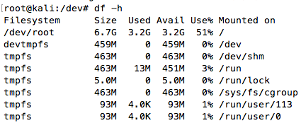

2. Browse to ~/dev and check the name of the partitions

~/dev# ls

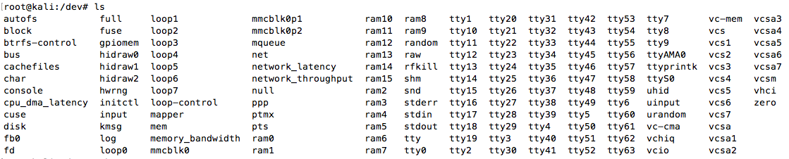

3. Run fdisk on the main block of memory

# sudo fdisk –uc /dev/mmcblk0 // -u: When listing partition tables, show sizes in ‘sectors’

// -c: Specify the compatibility mode to non-DOS mode

4. Input ‘p’ to see the partitions; notice that the entire block as 29.3 GiB available. (The screenshot below shows my blocks after repartitioning. Your second partition should be much smaller). Take note of the start value for the second partition (125001 in this example)

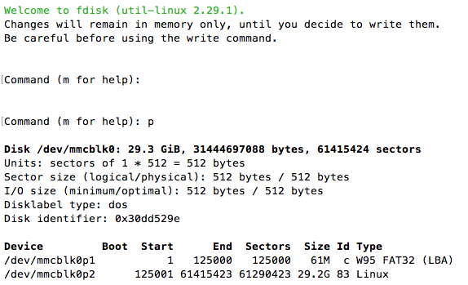

5. Delete the second partition by entering ‘d’ and ‘2’ when prompted for the partition number.

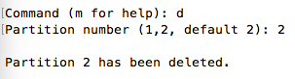

6. Create a new partition by entering ‘n’ and ‘2’ when prompted for the partition number.

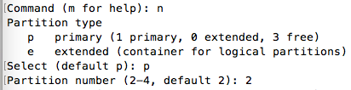

7. Set the start and end sectors for the partition (using the number found in 4) by entering the “First sector” and “Last sector” when prompted. For the last sector use the default by hitting enter. This should be the last sector on the SD.

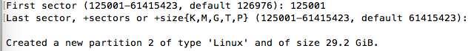

8. I was prompted with a warning saying “Partition #2 contains a ext4 signature.” “Do you want to remove the signature?” Enter ‘Y’ for yes.



9. Write the new partition to the SD by entering ‘w’.

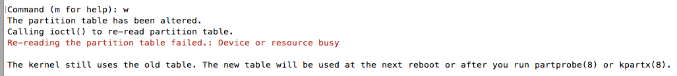

10. Reboot the system

# reboot



11. Resize the filesystem to fill the partition.

#sudo resize2fs /dev/mmcblk0p2

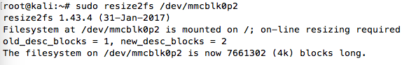

12. Ensure it worked by checking the filesystem sizes

#df –h

